A

Report

On

WALL MAGAZINE 2023

Department of PHILOSOPHY

Rabindra Mahavidyalaya, champadanga,hooghly
Session: 2022-23

Theme: VABACHAKRA (Buddhist concept)

Venue: Rabindra Mahavidyalaya,

champadanga,

room no. 71

Date:18TH August ,2023

Organizer: Department of Philosophy

Objectives:

- To enable the students to express their inner feelings.
- It also helps them in developing the positive and desirable qualities.
- The main objective of mobilizing wall magazine is to initiate writing tendency in pupil teacher and attract their attention on current incidents
- Development of soft skills.

- Ability to grow presentation skills, engage in meaningful discussion to arrive at a shared understanding their oral work, combining information.

- Enhancing students’ intelligence.

- Building students’ confidence

- Dealing with critical and argumentative situations

summary

Wall Magazine Report
A Wall Magazine is organized by the Department of Philosophy on 18th August 2023.Two more programs were held on that day, freshers welcome and Farewell. The topic of Wall Magazine was "VabaChakra". First prof.Iti Mukherjee, Professor of Economics Department, inaugurated the wall magazine on that day in the presence of professors and students. Students’ and professors from other departments were also present. The topic of wall magazine was presented in front of everyone by students and teaching faculty of philosophy department. The topic of wall magazine was presented in front of everyone by Arifa Khatun (student) and prof. SanchitaKheto of philosophy department. Teachers of other departments also gave speeches. Then everyone reaches room no 71 for the rest of the program. Along with some cultural events, such as recitals, dances, songs, speeches etc. are also held.
Wall magazine is an important means to enable the students to express their inner feelings. It also helps them in developing the positive and desirable qualities. The main objective of mobilizing wall magazine is to initiate writing tendency in pupil teacher and attract their attention on current incidents.

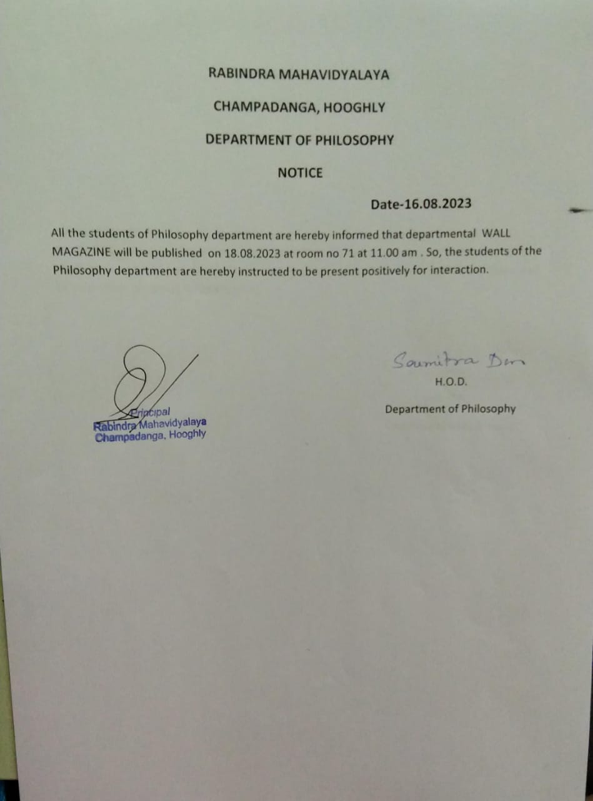

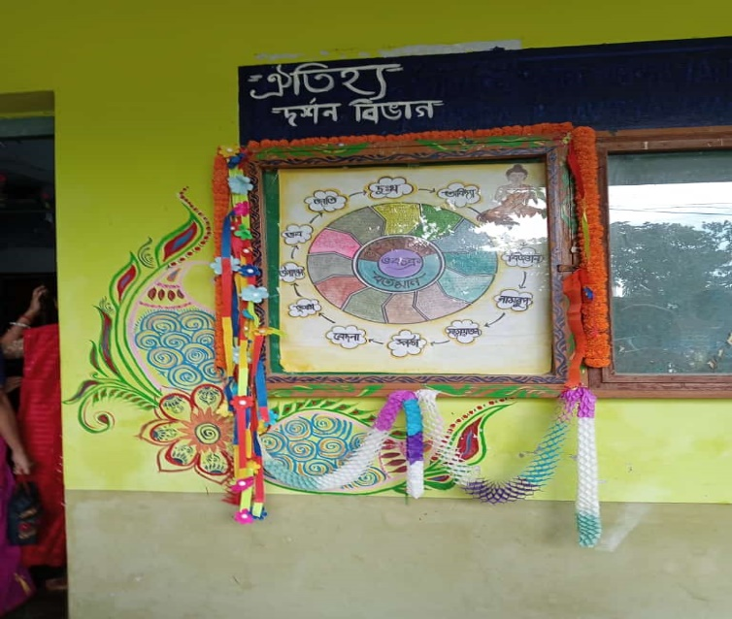
Theme: VABACHAKRA (Buddhist concept)

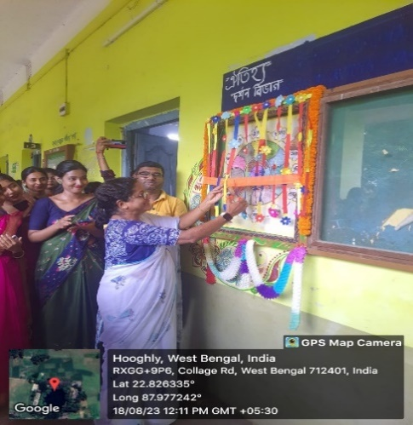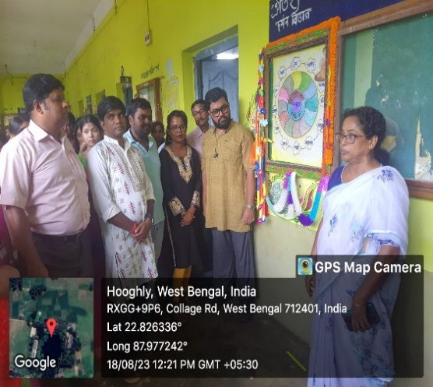
Inaugural speech by Prof. ItiMukharjee
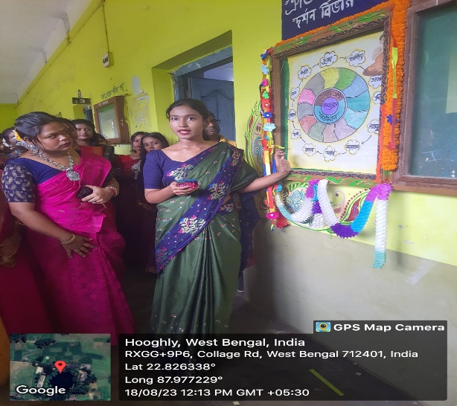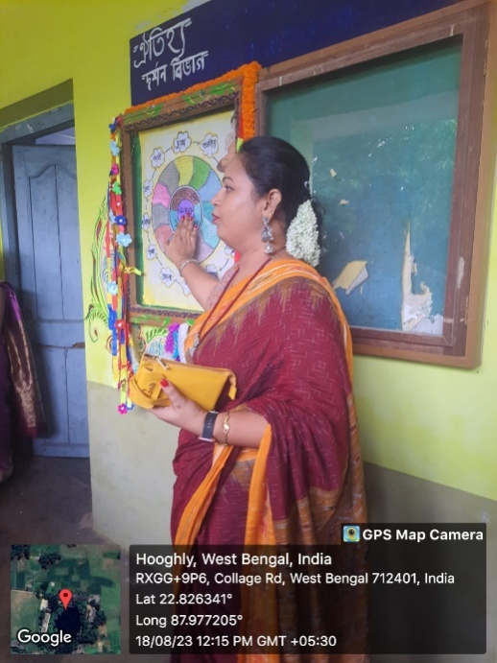
topic present by studentstopic present by Professor

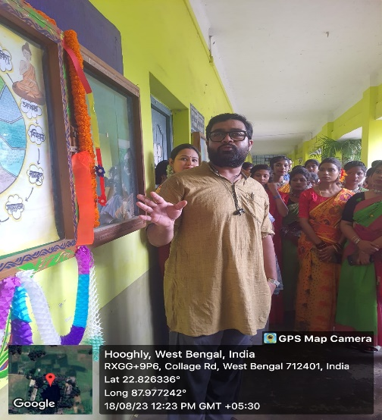
Another Departmental professor’s speech
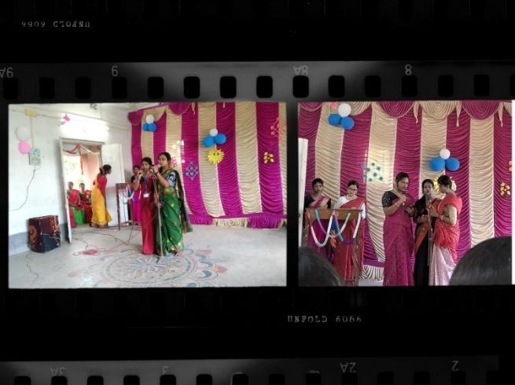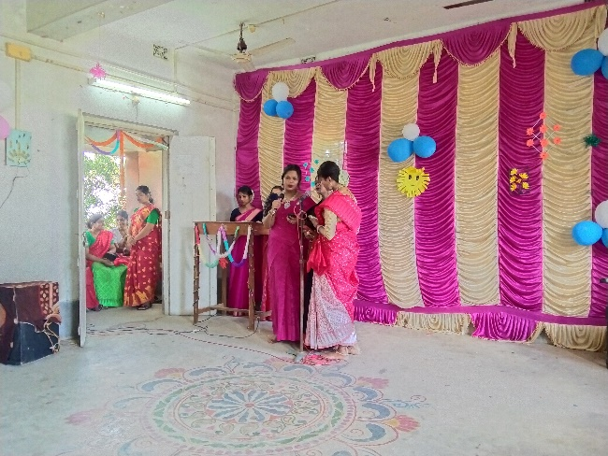
cultural performance by students’
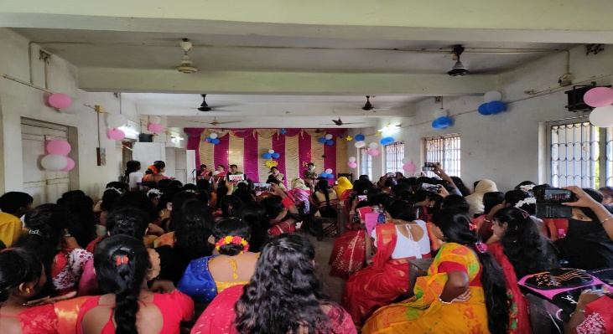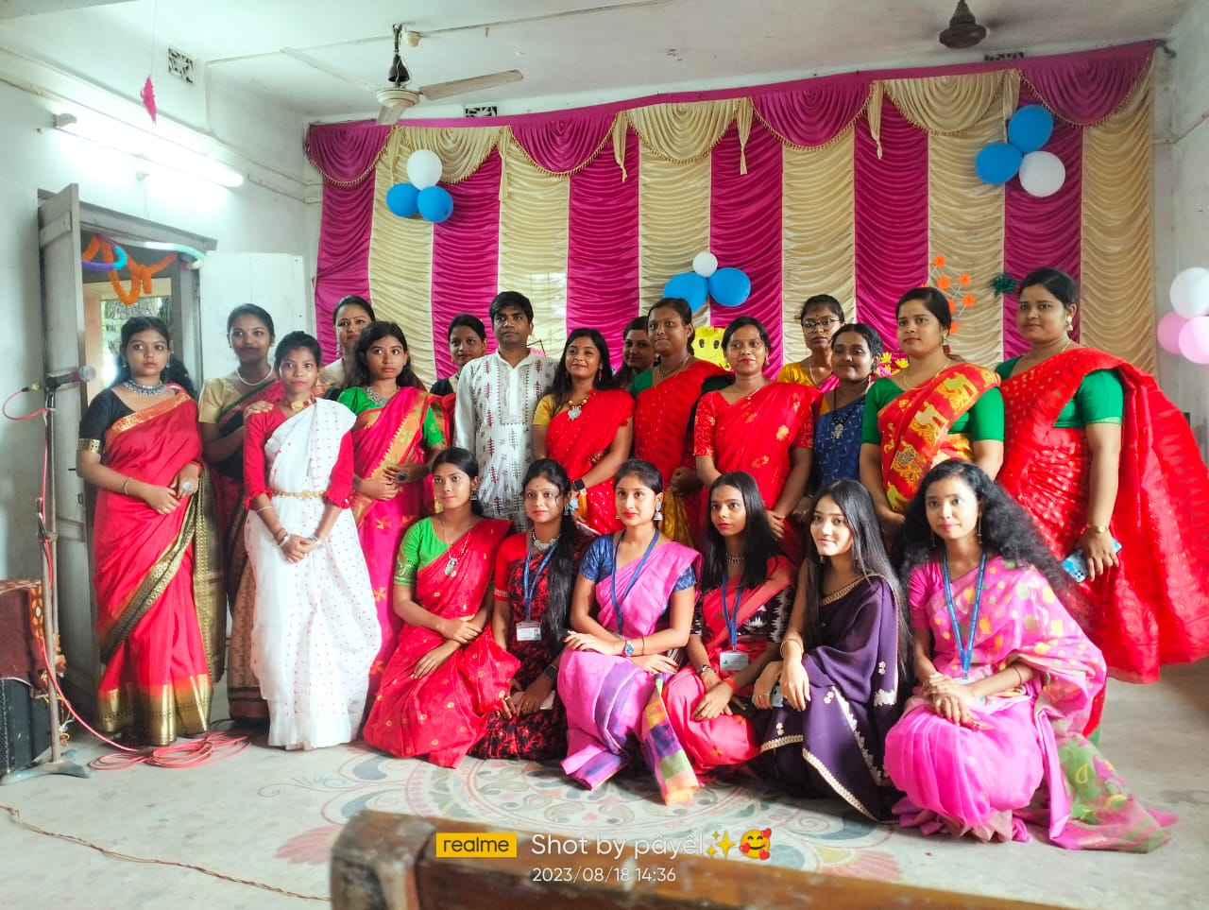
our students’
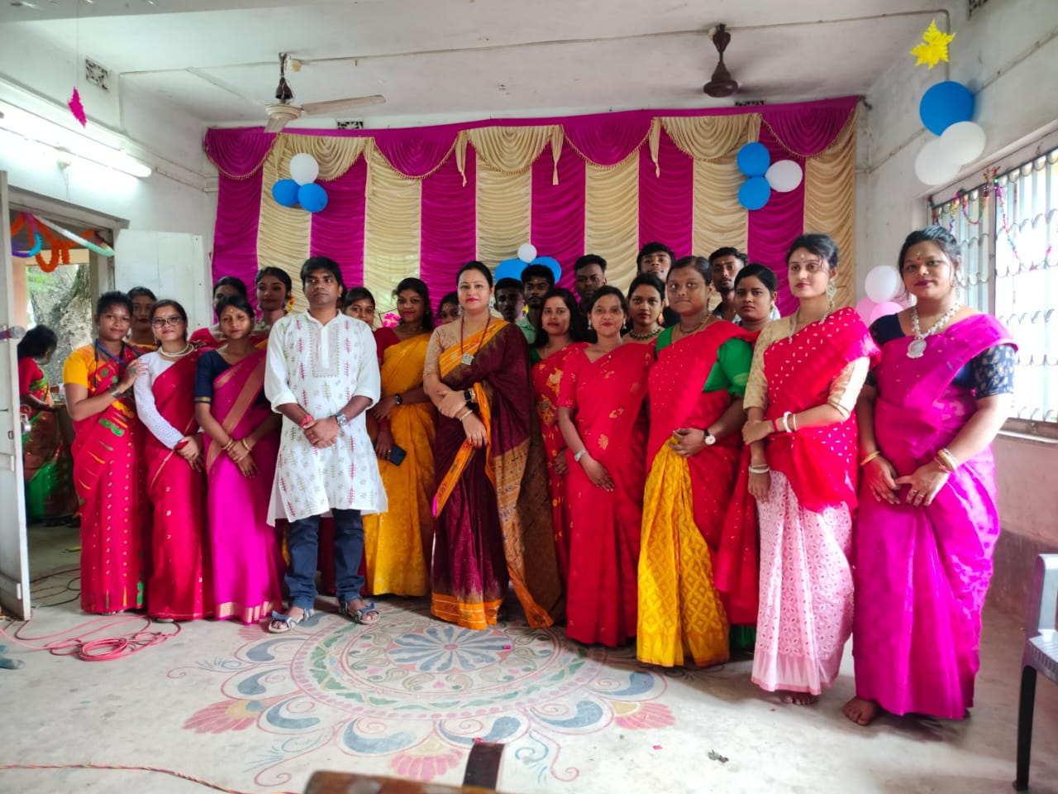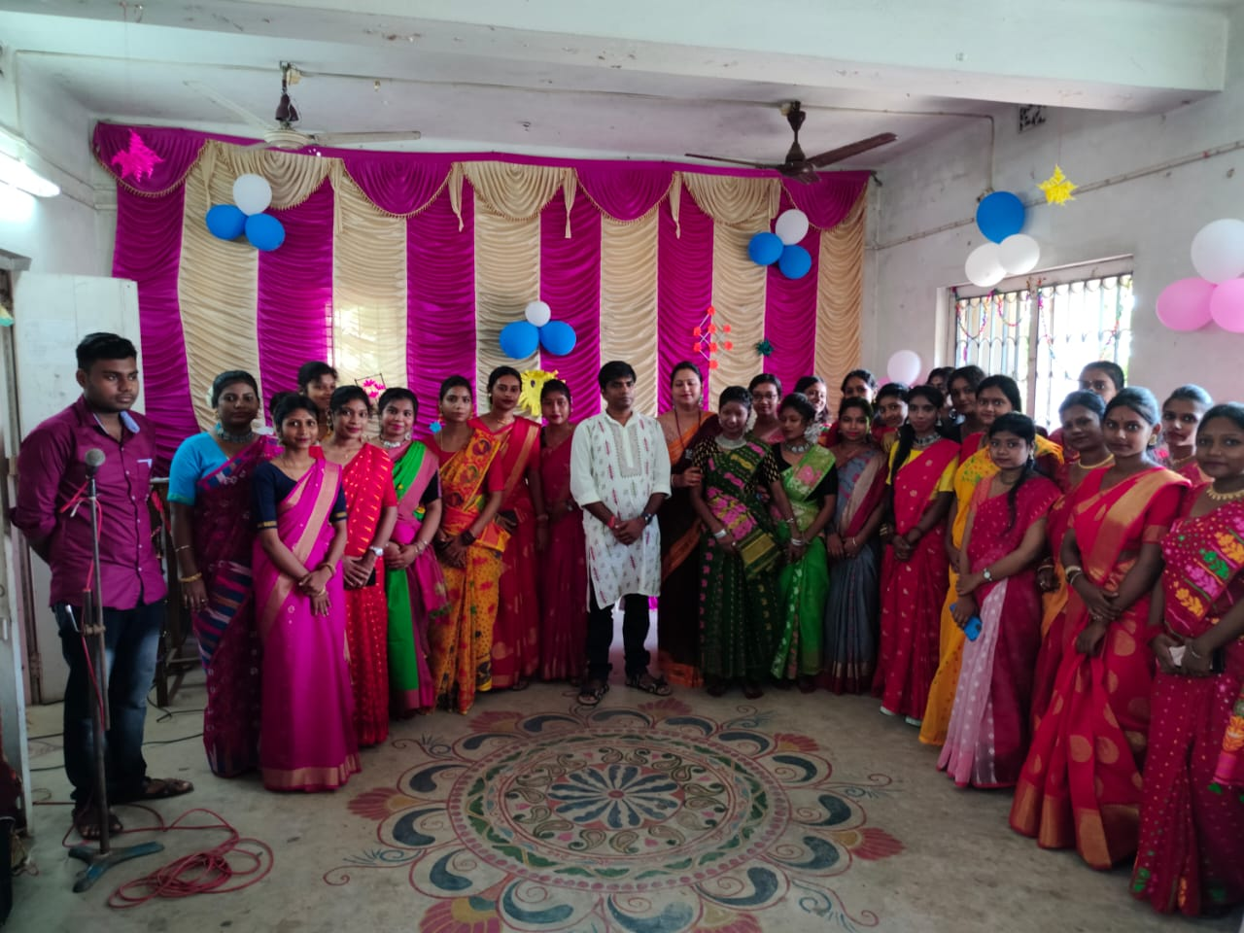
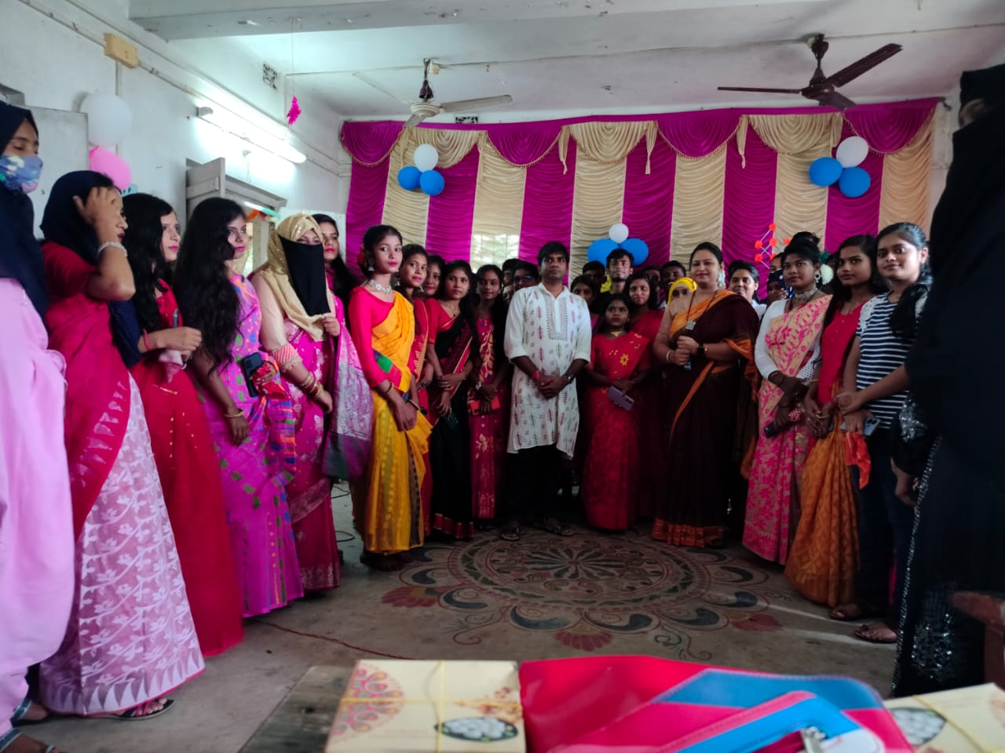

Our participant: 70
Male:20
Female:50

Tentative programmed schedule
- Inaugural session: 12 noon to 12.30 p.m.
- Theme present to audience: 12:30 p.m. to 1.00 p.m.
- Lunch break: 1.00 p.m. to 1:30 p.m.
- Cultural programmed: 1:30 p.m. to 4:30 p.m.

